SPORTS GAMES & CAMP PLACES IN BAUSKA REGION
GUEST HOUSE IECUPES  “Iecupes”, Iecava,  Bauskas nov.  Ph: +371 20606055; 26764637  E-mail: rgudlevskis@gmail.com    www.iecupes.lv    /iecupesviesunams |  |  |  |  | Outside view  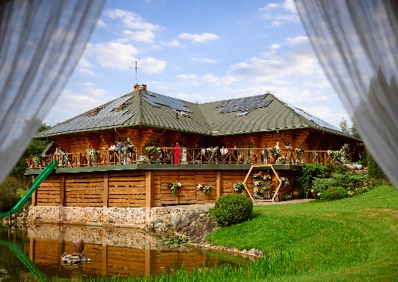 |  |  |  |  |  | Outside view  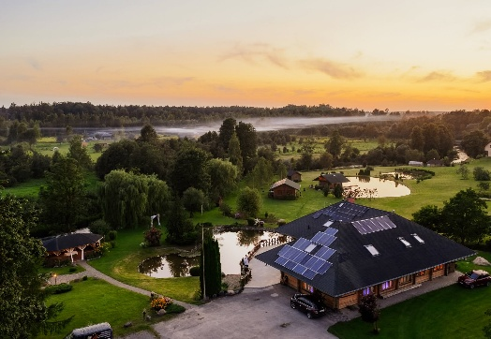 |  |  |  |  | Accommodation:  Guesthouse with 6 rooms for up to 65 people (a dormitory-style room is available for larger groups of ~15 people)  Camping cabin for 2 people  Camping cabin for 4 people  Recreation cabin (up to 15 people)
Catering:
Any nearby caterer can be organized (by prior arrangement)
 |  |  | Price, EUR/24h |  |  | Price, EUR/h |  |  |  |  |  |  |  | Max number of persons for participation
Guest house |  |  | 1500 |  |  | - |  |  |  |  |  |  |  | 80
Outdoors |  |  | - |  |  | - |  |  |  |  |  |  |  | 150
Camping cabin (for 2 people) |  |  | 40 |  |  |  |  |  |  |  |  |  |  | 2
Camping cabin (for 4 people) |  |  | 80 |  |  |  |  |  |  |  |  |  |  | 4
Recreation cabin |  |  | 400 |  |  |  |  |  |  |  |  |  |  | 15
SERVICES
Volleyball court | Basketball court |  |  | Soccer field |  | Sports equipment |  | Children's playground |  |  |  | Picnic place, grill, fireplace |  | Other activities |  |  | WC capacity |  | Notes
X |  |  |  |  |  | Volleyballs |  |  |  |  |  | X |  |  |  |  | 7 |  | 6 WC inside, 1 outdoor WC  + several in guest rooms
ADDITIONAL OPTIONS

Swimming area |  | Available
Sauna |  | From 60 EUR
Hot tub |  | From 60 EUR (up to 4 pers.)
Special offer |  | Discount staying for several nights – by prior arrangement!
GUEST HOUSE  POGAS  Dzimtmisa, Iecavas pag.,  Bauskas nov.  Ph: +371 22022053  E-mail: dk69@inbox.lv  /Viesu-Nams-Pogas-Iecavas |  |  |  |  | 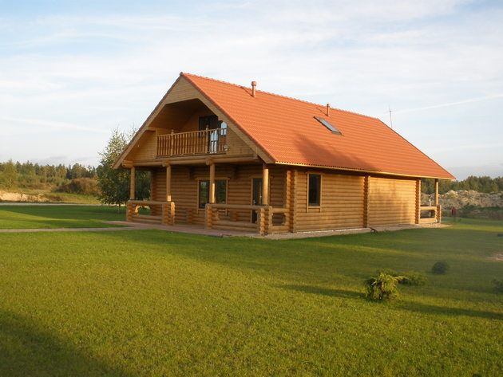  Outside view |  |  |  |  | Outside view  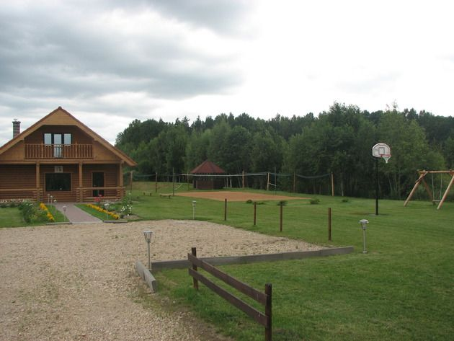 |  |  |  |  |  | Accommodation:  Up to 20 people, 3.50 EUR per person (if the banquet hall is rented)  Camping: up to 20 four-person tents, 5 EUR per tent  “Podziņas” vacation home for 2–4 people, 100 EUR
Catering:
Any nearby caterer can be organized (by prior arrangement).
Previous cooperation with café “Tornis”, “Taverna”, and other).
 |  | Price, EUR/24h |  |  |  |  | Price, EUR/h |  |  | Max number of persons for participation
Guest house |  | 220 |  |  |  |  | - |  |  | Up to 30 people
Vacation home “Podziņas” |  | 100 |  |  |  |  | - |  |  | 2-4 people
Outdoors |  | - |  |  |  |  | -
SERVICES
Volleyball court | Basketball court |  |  | Soccer field |  |  | Sports equipment |  | Children's playground |  |  |  | Picnic place, grill, fireplace |  | Other activities |  |  | WC capacity |  | Notes
X |  |  |  |  |  |  | For all sports – equipment included |  | X |  |  |  | X |  | Karaoke (free of charge) |  |  | 4 |  | 2 indoor WC  2 outdoor WC
 | X |  |  |  |  |  |  |  |  |  |  |  |  |  | Streetball court and mini soccer field |  |  |  |  | Sports courts/fields 1EUR/pers. or by prior arrangement!
 |  |  |  | X |  |  |  |  |  |  |  |  |  |  | Obstacle course (by prior arrangement)
ADDITIONAL OPTIONS
Swimming area | Available
SUP | 1 SUP: 10 EUR/h
Bicycles | 3 bicycles: 7 EUR/h
Sauna | 30 EUR
Hot tub | 60 EUR
Other | Large outdoor tent rental: 30 EUR
Special offer | Price for several days (from Friday to Sunday): 350 EUR

AMUSEMENT PARK LABIRINTI  “Bērziņi”, Zorģi, Iecavas pag.,  Bauskas nov.  Ph: +371 26320336  E-mail: info@labirinti.lv  www.labirinti.lv  /labirinti |  |  |  |  | 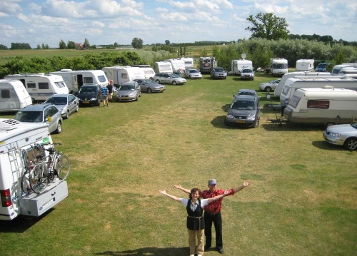  Outside view |  |  |  |  | Outside view  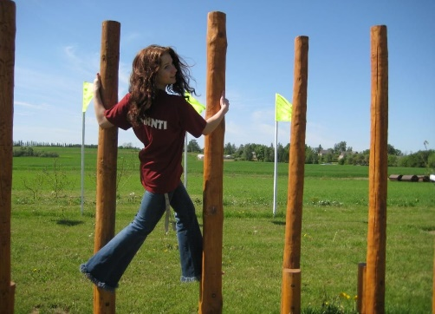 |  |  | Accommodation - camping:  32 camping sites + 20 places for caravans:  20 EUR/2 pers. + each next place 5 EUR  20 tent places: 5 EUR/pers.
Catering:
Any nearby caterer can be organized (by prior arrangement).

 |  |  | Price, EUR/24h |  |  |  | Price, EUR/h |  | Max number of persons for participation
Outdoors |  |  | - |  |  |  | 1.50/pers. |  | Max 200 pers.
SERVICES
Volleyball court | Basketball court |  |  | Soccer field |  | Sports equipment |  | Children's playground |  |  | Picnic place, grill, fireplace | Other activities |  | WC capacity | Notes
X |  |  |  | X |  | X |  | X |  |  | X | Amusement park with more than 20 activities (labyrinth, board games, trampolines, erudition and skill games, etc.) |  | 3
 |  |  |  |  |  |  |  |  |  |  |  | Go-karts 1.50 EUR/h
ADDITIONAL OPTIONS
Boat rental |  | One boat (price included in the entrance fee)

GUEST HOUSE  SATEKAS  Vecumnieku pag., Bauskas nov.  Ph: +371 28630062; 26184122  E-mail: info@satekas.lv  /viesumajasatekas |  |  |  |  | Outside view  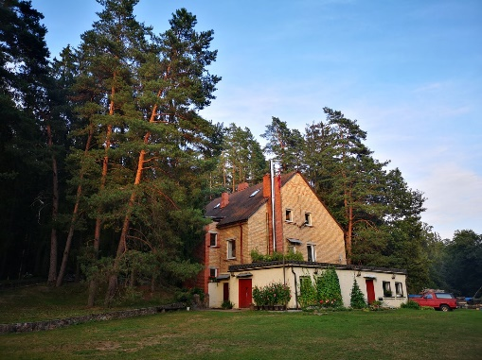 |  |  |  | 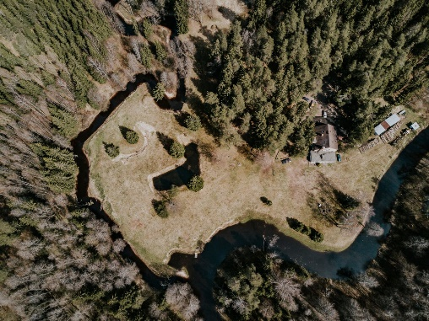  Outside view |  |  | Accommodation:  8 rooms available (up to 40 people total) 7.50 EUR/person.  Tent sites available
Catering:
Any nearby caterer can be organized (by prior arrangement).
 |  |  | Price, EUR/24h |  |  |  | Price, EUR/h | Max number of persons for participation
Outdoors |  |  | - |  |  |  | - | 100
SERVICES
Volleyball court | Basketball court |  |  | Soccer field |  | Sports equipment |  | Children's playground |  | Picnic place, grill, fireplace | Other activities |  | WC capacity | Notes
 |  |  |  | Goal |  | X |  | X |  | X |  |  | 5
 |  |  |  |  |  |  |  |  |  |  |  |  |  | Possible to park up to 20 cars
ADDITIONAL OPTIONS
Swimming area |  | Available
SUP |  | 3 SUP (from May until September, by prior arrangement)
Sauna |  | Swimming pool included: 30 EUR/3h
Special offer |  | Long term rental – by prior arrangement!

SPORTS & RECREATION PARK PĪLĀDŽI  Stelpe, Bauskas nov.  Ph: +37126439235; 29454683  E-mail: infopiladzis@gmail.com  www.piladzis.lv  /PiladzuMototrase |  |  |  | Outside view  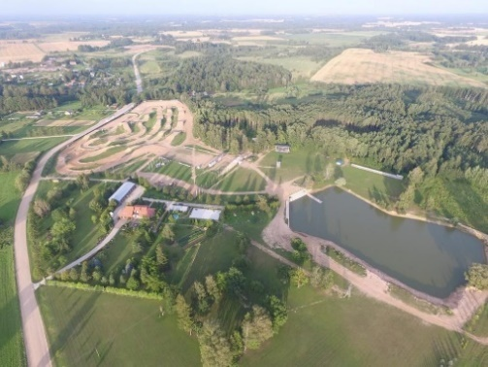 |  |  | Outside view  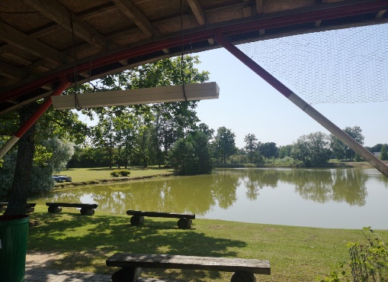 |  |  | Accommodation:  Cottage: up to 4 people, 200 EUR (12 available)  Campground for trailers and RVs,  tent sites also available: up to 48  sites in total  Tent site: 5 EUR + VAT  18 restrooms, 18 showers
Catering:
- Cooperates with several caterers (by prior arrangement)
- Other caterer – admission fee (by prior arrangement)
 |  |  | Price, EUR/24h |  | Price, EUR/h |  | Max number of persons for participation
Recreation Park |  |  | By prior arrangement! |  | By prior arrangement! |  | Max 50-60 pers., large event tent – up to 600 pers.
Outdoors |  |  | By prior arrangement! |  | By prior arrangement! |  | 25 000
SERVICES
Volleyball court | Basketball court |  | Soccer field |  | Sports equipment | Children's playground |  | Picnic place, grill, fireplace | Other activities | WC capacity | Notes
X | X |  | X |  | X | X |  | X | Walking trail in the woods | 15 | + WC rental (depends on the number, how much needed on the event time)
 |  |  |  |  |  |  |  |  |  |  | Drinking water connection. Illuminated territory in the evenings.
ADDITIONAL OPTIONS
Swimming area |  | Available
SUP |  | Several SUP (by prior arrangement)
Boat rental |  | Available
Hot tub |  | Up to 6 pers.
Other |  | Tent rental for events: stage, bar counter, café included / Wi-Fi / Portable grill
Special offer |  | Mototrack rental, quad bike rides

RECREATION COMPLEX  VALLE  “Mežmaļi-3”, Valle  Bauskas nov.  Ph.: +371 29174814  E-mail: burtukalps@inbox.lv  www.valle.lv |  |  |  |  | 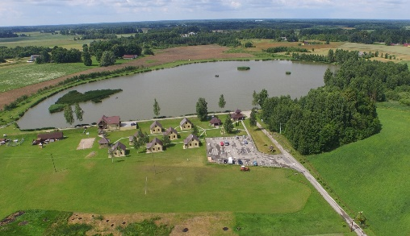  Outside view |  |  | Outside view  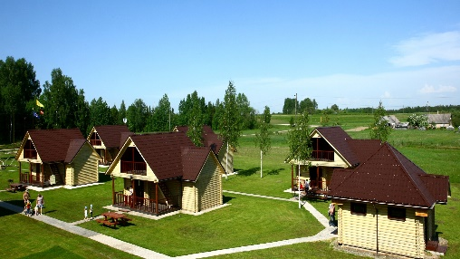 |  |  | Accommodation:  Up to 65 people  7 cottages and 1 guest house, starting at  25 EUR/person  Tent site: 10 EUR/day
Catering:
Any nearby caterer can be organized (by prior arrangement).
 |  |  | Price, EUR/24h |  |  | Price, EUR/h | Max number of persons for participation
Complex |  |  | 1400 |  |  | -
Outdoors |  |  | - |  |  | - | Max. 200 pers.
SERVICES
Volleyball court | Basketball court |  |  | Soccer field |  | Sports equipment | Children's playground |  | Picnic place, grill, fireplace | Other activities |  | WC capacity | Notes
X | X |  |  | Goal |  | X | X |  | X |  |  | 8 | 2 indoor WC,  6 outdoor WC + WC inside cottages
 |  |  |  |  |  |  |  |  |  | Sightseeing objects nearby (Valle church, museum “Zvanītāju Bukas”) |  |  | Event tent rental  (16m x 4m) (3m x 3m) A wooden canopy also available.
ADDITIONAL OPTIONS
Sauna |  | With hot tub: 50 EUR/3h
Other |  | Transport services (for example, to forest for berry or mushroom picking, to river boating, transfer from/to airport “Rīga”, railway station or bus station. Fishing.
Special offer |  | One cottage house is adjusted for people with disabilities/special needs.

CAMPING, BOAT RENTAL  LUTAUŠI  "Lutauši", Kurmenes pag.,  Bauskas nov.  Ph.: +371 28354626  E-mail: andzelabrica@inbox.lv  www.laivunomalutausi.lv  /laivunomalutausi |  |  |  | 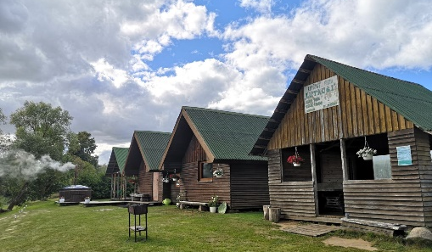  Outside view |  |  |  | 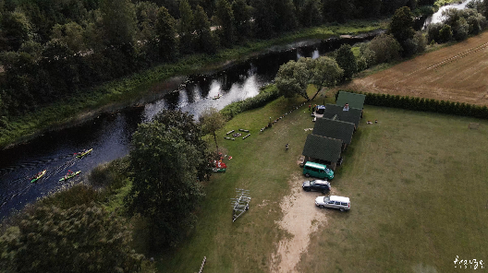  Outside view |  | Accommodation:  Camping: up to 10 pers.  5 camping sites  Tent places: 3 EUR/pers./day (all territory included)  Children up to 6 years old – entrance free of charge!
Catering:
Any nearby caterer can be organized (by prior arrangement).
 | Price, EUR/24h |  | Price, EUR/h |  |  | Max number of persons for participation
All territory | By prior arrangement! |  | - |  |  | Max 80 pers.
SERVICES
Volleyball court | Basketball court |  | Soccer field |  | Sports equipment |  | Children's playground |  | Picnic place, grill, fireplace | Other activities | WC capacity | Notes
X | X |  | X |  | X |  |  |  | X | Floorball | 4
ADDITIONAL OPTIONS
Swimming area |  | Available
SUP |  | Several SUP, from 20 EUR/day
Boat rental |  | Canoe and kayak, from 15-25 EUR/day
Hot tub |  | 50 EUR
Other |  | Open-air stage for events

DISC GOLF PARK MEŽAVOTI  “Kalnavotiņi”, Iecavas pag.  Bauskas nov.  Ph: +371 26445994  E-mail: discgolfmezavoti@gmail.com  /mezavotidiscgolf |  |  |  | 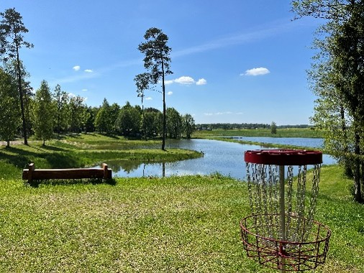  Outside view |  |  |  |  | Outside view  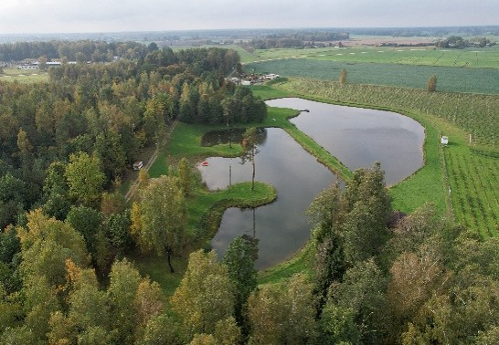 |  | Accommodation:  Tent place: from 5 EUR/pers.  5-10 camping sites
Catering:
Any nearby caterer can be organized (by prior arrangement).
Previous cooperation with café “Viestarti”.

 |  |  | Price, EUR/24h |  | Price, EUR/h |  | Max number of persons for participation
Picnic place (with canopy) |  |  | 30 + 5 EUR/pers. |  | 10 |  | 30
Outdoors (all territory with canopy) |  |  | 150 + 5 EUR/pers. |  | 20 |  | Max 150 pers.
SERVICES
Volleyball court | Basketball court |  |  | Soccer field |  | Sports equipment |  | Children's playground |  | Picnic place, grill, fireplace | Other activities | WC capacity | Notes
X |  |  |  |  |  | X |  | X |  | X | Disc golf | 3 | Disc golf  5 EUR/pers.
ADDITIONAL OPTIONS
Swimming area |  | Available
SUP |  | 10 EUR
Boat rental |  | 2 water catamarans, 1 boat, 3 quad cycles, 45 EUR/h
Other |  | Residental wagon: 35 EUR/diena (with 2 beds), including water, electricity, WC.

YOUTH CENTER KLINTS  Kurmene, Bauskas nov.  Ph.: 20038364  E-mail: kjcklints@gmail.com  /KJC5115 |  |  |  |  | 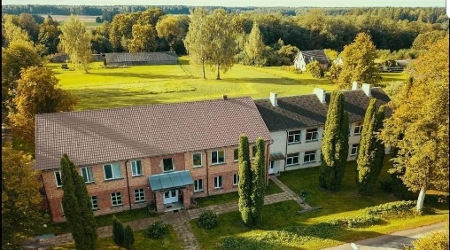  Outside view |  |  |  | 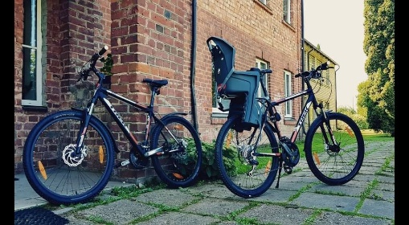  Outside view |  | Accommodation:  Up to 30 pers.: 25eur/pers.  30 tent places: 3 EUR pers.  5 camping sites: 20 EUR/1 place (without electricity, drainage, but including water and shower)
Catering:
Catering is provided by the local provider “IK Pie Mēmeles"
10 EUR/day/pers., 3 meals included
 |  |  | Price, EUR/24h |  |  |  | Price, EUR/h | Max number of persons for participation
Youth center |  |  | 50-70 EUR |  |  |  | - | Rooms with 4–6 beds; can accommodate up to 25 people in total
Outdoor area |  |  | - |  |  |  | - | The municipal sports field located in the adjacent area
SERVICES
Volleyball court | Basketball court |  |  | Soccer field |  | Sports equipment |  |  | Children's playground | Picnic place, grill, fireplace | Other activities | WC capacity | Notes
X | X |  |  | X |  | X |  |  |  | X | Badminton | Up to 50 pers.
ADDITIONAL OPTIONS
Swimming area |  | Available
SUP |  | 20 EUR/day
Bicycle rent |  | 3 bicycles: 15 EUR/day
Other |  | Photo studio
Special offer |  | Guided excursions in Kurmene manor, park, church

RECREATION COMPLEX  ROŽMALAS  Nameju iela 2, Ceraukste, Bauskas nov.  Ph.: +371 26564580  E-mail: info@rozmalas.lv  www.rozmalas.lv    /rozmalas |  |  |  | 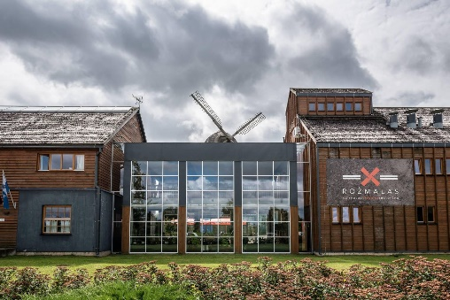  Outside view |  |  |  | Outside view  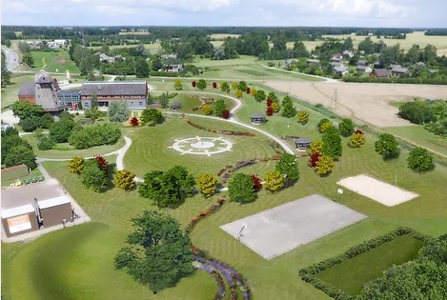 |  | Accommodation:  Up to 70 pers., from 70 EUR  Tent place: 10 EUR/tent
Catering:
Coffee break: from 10 EUR/pers.
Lunch: from 18 EUR/pers. 2-3 meal menu
Diner: from no 25 EUR/pers. 2-3 meal menu
 |  |  | Price, EUR/24h |  | Price, EUR/h | Max number of persons for participation
Complex |  |  | By prior arrangement! |  | - | Max. amount indoors up to 100 pers., in the territory up to 1000 pers.
Outdoors |  |  | By prior arrangement! |  | -
SERVICES
Volleyball court | Basketball court |  |  | Soccer field | Sports equipment |  | Children's playground |  | Picnic place, grill, fireplace | Other activities | WC capacity | Notes
X | X |  |  | X |  |  | X |  | X |  | 10 | Picnic place: 10 EUR/ up to 10 pers.
ADDITIONAL OPTIONS
Sauna |  | Complex: 100 EUR/h | Sauna, hot tub: 30 EUR/h.
Other |  | Excursion in the mill with pie baking: 6 EUR/pers.  Excursion in the mill with pie baking and soup in the lunch: 12 EUR/pers.

GLEMPING  MAZIE MEŽGAĻI  Brunavas pag., Bauskas nov.  Ph.: +37120474158  E-mail: info@maziemezgali.lv  www.maziemezgali.lv |  |  |  |  | 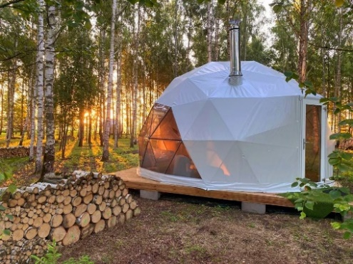  Outside view |  |  |  | Outside view  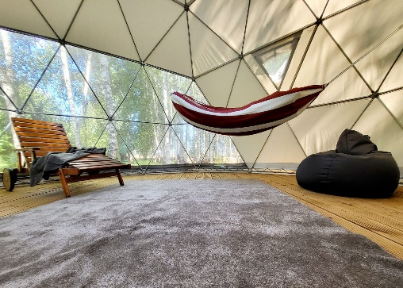 |  |  | Accommodation:  For groups (10–200 people): a hostel in the school building  Glamping (up to 40 people)  Apartments in the manor house (up to 30 people)
Catering:
Any nearby caterer can be organized (by prior arrangement).
 |  |  | Price, EUR/24h |  |  |  | Price, EUR/h | Max number of persons for participation
Dome tent "Ozoli" |  |  | 140 |  |  |  | - | Up to 25 pers.
Dome tents "Bērzi" (x6) |  |  | 65 |  |  |  | - | Up to 6 pers.
Outdoors |  |  | By prior arrangement! |  |  |  | -
Apartments in the manor house |  |  | 14 |  |  |  | - | Up to 200 pers.
SERVICES
Volleyball court | Basketball court |  |  | Soccer field |  | Sports equipment |  | Children's playground |  | Picnic place, grill, fireplace | Other activities |  | WC capacity | Notes
X | X |  |  | X |  | X (for additional fee) |  | X |  | X | Snorkeling |  | 18
ADDITIONAL OPTIONS
Swimming area |  | Available
SUP |  | 15 available: 5 EUR/hour or 20 EUR/day
Boat rent |  | 12 available: 8 EUR/h, including 5 crystal-clear boats
Sauna/hot tub |  | Portable sauna and hot tub available
Other |  | Apartament in manor house, massage ayurveda, meditation room, possibility to organize a snorkeling event, underwater exploration (owners has a certificate for camp organisation)
Special offer |  | Until 31.05 - 50% discount!

Recreation site “Saknes”  "Saknes", Kurmenes pag., Bauskas nov.  Phone: 29107087  E-mail: agris393@inbox.lv   www.avsaknes.lv/atputasvietasaknes | Outside view  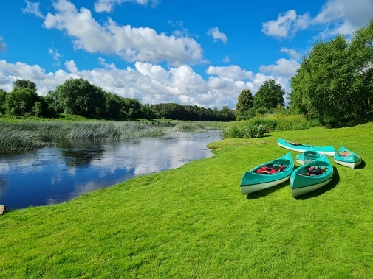 | Outside view  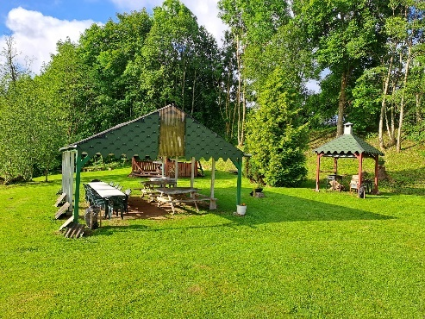 | Accommodation Camping site for up to 100 people.  Price: 5 EUR per person.
Catering:
-

 | Price, EUR/24h | Price, EUR/h | Max number of persons for participation
Recreation Center | By prior arrangement! | -
Outdoor area | By prior arrangement! | -
SERVICES
Volleyball court | Basketball court | Soccer field | Sports equipment | Children's playground | Picnic place, grill, fireplace | Other activities | WC capacity | Notes
X |  | X | X | X | X | Table teniss | 1
ADDITIONAL OPTIONS
Sauna | -
Other | -

